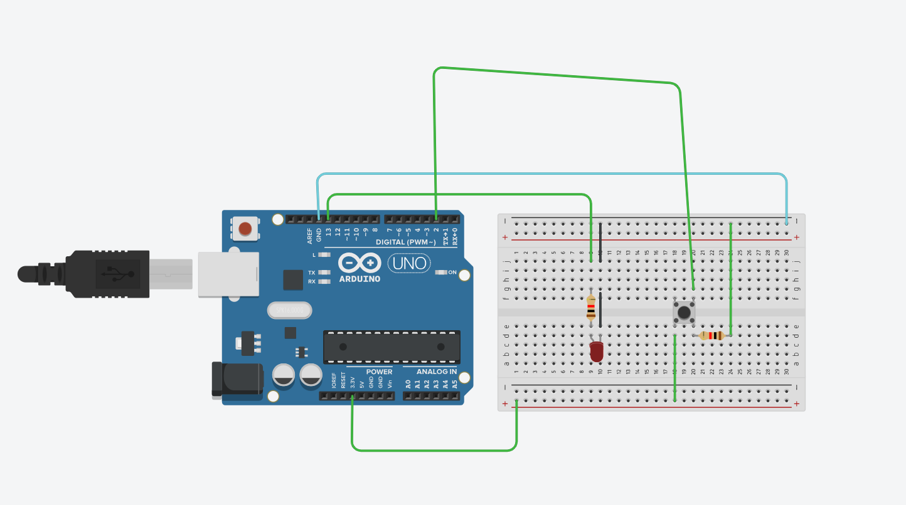

Code :- int led = 13;
int pushButton = 2;
void setup()
{
Serial.begin(9600);
pinMode(pushButton, INPUT);
pinMode(led, OUTPUT);
}

void loop()
{
int buttonState = digitalRead(pushButton);
Serial.println (buttonState);
if(buttonState == 1){
digitalWrite(led, HIGH);
} else {
digitalWrite(led, LOW);
}
delay(100);
}

